## REAL-ESTATE WEBSITE (HAMESHOMES.COM)

*A*

***Major Project Report***

*Submitted*

*In partial fulfillment*

*For the award of the Degree of*

## BACHELOR OF TECHNOLOGY

***In Department of Computer science and Engineering***

**SUBMITTED BY: GUIDED BY: SUBMITTE TO:**

Chirag Jain (18etccs024) Aditya Maheshwari Head of department

Hardi Jain (18etccs036) (Assistant Professor) computer science

Laxmi Kunwar Panwar

(18etccs058)



### Department of Computer Science and Engineering TECHNO INDIA NJR INSTITUTE OF TECHNOLOGY

RAJASTHAN TECHNICAL UNIVERSITY

**May 2022**



### TECHNO INDIA NJR INSTITUTE OF TECHNOLOGY



## CERTIFICATE

This is to certify that this project report **“Real-Estate Website”** is the confide work of **“Chirag Jain, Hardi Jain, Laxmi Kunwar Panwar”** who have carried out the project work under my supervision. I approve this project for submission of the Bachelor of Technology in the **Department of Computer Science and Engineering, Techno India NJR Institute of Technology**, affiliated to Rajasthan Technical University, Kota.

##### Mr. Aditya Maheshwari

**Head of department Assistant professor**

Department of Computer Science Department of Computer Science



## ABSTRACT

### Purpose

* 1. ***Introduction***

This Software Requirements Specification provides a complete description of all the functions and specifications of the Real-estate website.

We are bringing real estate online in order to make it more accessible and much organized. As now-a-days frauds in real estate have increased on an alarming rate. Real estate has become very expensive and many people can't find affordable homes and have to suffer getting settled.   
People can’t find a better way for investments and invest in wrong property and suffer losses. Data related to properties are very difficult to fetch and find now-a-days.

* 1. ***Scope***

Scope of this project is very broad.

Few of them are: -

* + This can be used in educational institutions as well as in the corporate world.
  + Business relationship with comprehensive online services like transport, banking etc.
  + Affiliate Marketing Systems, Website Design, and Development and Search Engine Optimization.
  + Integration with other standard Application Software Products & Booking Engines/ Platforms.

### Document overview

The remainder of this document is 8 chapters, the first providing introduction of the project. It lists all the functions performed by the system. The second chapter consists of software requirements specification. The third chapter provides details about system analysis and design. The fourth chapter gives data dictionary information. The fifth chapter consists of snapshots of the complete project. The sixth chapter gives testing for the project. The seventh chapter tells about the conclusion and future enhancements of the project. The final chapter concerns with the bibliography.

## ACKNOWLEDGEMENT

It gives me immense pleasure to express my deepest sense of gratitude and sincere thanks to my highly respected and esteemed guide **Mr. Aditya Maheshwari (Assistant Professor), TINJRIT** for their valuable guidance, encouragement and help for completing this work. Their useful suggestions for this whole work and co-operative behavior are sincerely acknowledged.

I would like to express my sincere thanks to **Faculties of CSE Department TINJRIT** for giving me this opportunity to undertake this project.

I also wish to express my indebtedness to my parents as well as my family member whose blessings and support always helped me to face the challenges ahead.

At the end I would like to express my sincere thanks to all my friends and others

who helped me directly or indirectly during this project work.

**Place : Udaipur Chirag Jain (18etccs024)**

**Date : Hardi Jain (18etccs036)**

**Laxmi Kunwar Panwar**

**(18etccs058)**



## TABLE OF CONTENTS

**Table of Contents**

ABSTRACT iii

ACKNOWLEDGEMENT iv

TABLE OF CONTENTS v

LIST OF TABLES …………………………………………………………………………………………………….vii

LIST OF FIGURES …………………………………………………………………………………………………..viii

CHAPTER – 1 Introduction .......................................................................................................................................1-5

Introduction ......................................................................................................................................................................2

1.1. Purpose .....................................................................................................................................................................2 1.2. Overall Description ..................................................................................................................................................4

**CHAPTER – 2 Software Requirement Specification ..........................................................................................6-20**

2.1. Purpose................................................................................................................................................……………7

2.2. Overall Description ...............................................................................................................................................9

2.2.1. Functional Requirements definitions ..............................................................................................…………...9

2.2.2. Use Cases ...........................................................................................................................................................9

2.2.3. Non – Functional Requirements ......................................................................................................................14

2.3. Requirement Specification ..................................................................................................................................15

2.3.1. External interface specifications ......................................................................................................................15

2.3.2. Functional Requirements .................................................................................................................................15

2.4. Hardware Specification ......................................................................................................................................20

2.5. Software Specification .......................................................................................................................................21

2.6. Hardware and Software Requirements in detail ................................................................................................21

**CHAPTER – 3 System Analysis and Design ...................................................................................................22-30**

3.1. Study & Weaknesses of current system ............................................................................................................23

3.2 Requirements of new system ..................................................................................................................24

3.3. Feasibility Study ................................................................................................................................... 24

3.4. Features of new System ........................................................................................................................25

3.5. Data flow diagram ................................................................................................................................26

3.6. UML Modeling......................................................................................................................................28

3.6.1. Activity Diagram ...............................................................................................................................28

3.6.2. Context Diagram ...............................................................................................................................30

**CHAPTER – 4 Data Dictionary ..........................................................................................................31-36**



4.1. Table Details ........................................................................................................................................32

4.2. E-R Diagram ........................................................................................................................................36

**CHAPTER - 5 Screen Shots ...............................................................................................................37-48**

5.1 User Side ……………………………………………………………………………………………..38

**CHAPTER – 6 Testing .......................................................................................................................49-55**

**CHAPTER – 7 Conclusion and Future Enhancements ..................................................................56-58**

7.1. Limitations .........................................................................................................................................57

7.2. Future Enhancements ........................................................................................................................58

7.3. Conclusion .........................................................................................................................................58

**CHAPTER – 8 Bibliography .................................................................................................................59**

**List of Tables**



|  |  |  |
| --- | --- | --- |
| **Table No.** | **Table Name** | **Page No.** |
| Table 2.1 | Glossary | 7 |
|  | **Use Cases** |  |
| Table 2.2 | Access Home page | 15 |
| Table 2.3 | Admin login or signup | 15-16 |
| Table 2.4 | Manage Content | 16-18 |
| Table 2.5 | User selects, filter, view, rent or buy property, apply for a job or financing. | 19-20 |
|  | **Database Design** |  |
| Table 4.1 | Admin Login | 32 |
| Table 4.2 | Category | 33 |
| Table 4.3 | Request Details | 33 |
| Table 4.4 | Contact Us Details | 33 |
| Table 4.5 | Property Details | 34 |
| Table 4.6 | Testimonials | 34 |
| Table 4.7 | Financial Applications | 34 |
| Table 4.8 | Employment Applications | 35 |
| Table 6.1 | Test report with test data | 54-55 |



**List of Figures**

|  |  |  |
| --- | --- | --- |
| **Figure No.** | **Figure Name** | **Page No.** |
|  | **Use Cases** |  |
| Figure 2.2.2a | Access Home page | 10 |
| Figure 2.2.2b | Manage Content | 11 |
| Figure 2.2.2c | Admin Login | 12 |
| Figure 2.2.2d | User selects, filter, view, rent or buy property | 13 |
|  | **Data Flow Diagrams** |  |
| Figure 3.1 | USER DFD Level 2 | 26 |
| Figure 3.2 | Admin (DFD Level 2) | 27 |
|  | **UML Modelling** |  |
|  | *Activity Diagrams* |  |
| Figure 3.10 | Activity Diagram for Admin | 26 |
| Figure 3.11 | Activity Diagram for User | 27 |
| Figure 3.12 | Context Diagram | 30 |
| Figure 4.1 | E-R Diagram | 36 |



***CHAPTER – I INTRODUCTION***



**Introduction**

##### Purpose

###### Introduction

This Software Requirements Specification provides a complete description of all the functions and specifications of the Real-estate website.

We are bringing real estate online in order to make it more accessible and much organised. As now-a-days frauds in real estate have increased on an alarming rate. Real estate has become very expensive and many people can't find affordable homes and have to suffer getting settled.   
People can’t find a better way for investments and invest in wrong property and suffer losses. Data related to properties are very difficult to fetch and find now-a-days.

###### Scope

Scope of this project is very broad.

Few of them are: -

* + This can be used in educational institutions as well as in the corporate world.
  + Business relationship with comprehensive online services like transport, banking etc.
  + Affiliate Marketing Systems, Website Design, and Development and Search Engine Optimization.
  + Integration with other standard Application Software Products & Booking Engines/ Platforms.

###### References

* <https://concretecms.org>
* <https://www.w3schools.com/html>
* <https://www.javatpoint.com/javascript-tutorial>
* <https://getbootstrap.com>
* <https://github.com>

###### Document overview

The remainder of this document is 8 chapters, the first providing introduction of the project. It lists all the functions performed by the system. The second chapter consists of software requirements specification. The third chapter provides details about system analysis and design. The fourth chapter gives data dictionary information. The fifth chapter consists of snapshots of the complete project. The sixth chapter gives testing for the project. The seventh chapter tells



about the conclusion and future enhancements of the project. The final chapter concerns with the bibliography.

This document is meant for describing all the features and procedures that were followed while developing the system.

This document specially mentions the details of the project how it was developed, the primary requirement, as well as various features and functionalities of the project and the procedures followed in achieving these objectives.

Real-estate website is developed to provide some smooth process in buying and selling the properties. It also provides transparency so that is also solves the problem of frauds and malpractices in the Real-estate world which is very common now a days.  
  
 It also provides a better and more easy way for the users to find affordable or any property they want to rent or buy. This website also provides loan options and also insurance options for their houses. As it is a web-based solution so it can be accessed from anywhere in the world.

With the effective use, any user can use the “Real-Estate Website” for finding th properties they want in affordable prices and in a very easy and more convenient way.



##### Overall description

* We have developed a website for real estate operations in order to make it more accessible and much organised which solves a number of problems faced by consumers and brokers.
* This website provides easy way to find affordable houses and properties.
* It also provides easy ways for home insurances.
* Site provides online real-estate service committed to helping you make wise and profitable decisions related to buying, selling, renting and leasing of properties, in IOWA.

###### Functional requirements definitions

Functional Requirements are those that refer to the functionality of the system, i.e., what services it will provide to the user. Nonfunctional (supplementary) requirements pertain to other information needed to produce the correct system and are detailed separately.

###### Use cases

This system will be used in four User Modules which are Administrator, User. As all of these have different requirements the modules are designed to meet their needs and avoid any type of confusion. The Uses of all four User Modules have been described below.

1. User can do the following functions in the Administrator Module
   * Add & Edit Category
   * Add & Edit property listing
   * Add & Edit property description
   * Remove property
   * Add/edit/delete Forms
   * Add/Edit/Delete Testimonials
   * Add/Edit/Delete Pages
   * Manage Members
   * Add & Edit property images



1. User can do the following functions in the User Module
   * Can visit the listed sites
   * Filter the sites according to requirement
   * View the description of the property
   * Can request more information about the property
   * Buy a property
     1. ***User characteristics***

The user should be familiar with the Internet.

The user should be familiar with the property related terminologies.

#### Constraints

Limited to HTTP/HTTPS.

Real-life payment options not available.  
No multilingual support



# CHAPTER – II

***SOFTWARE REQUIREMENT SPECIFICATION***



### Software Requirement Specification

##### Purpose

###### Introduction

This Software Requirements Specification provides a complete description of all the functions and specifications of the website Online Examination System.

The main objective of on-line test simulator is to efficiently evaluate the candidate thoroughly through a fully automated system that not only saves lot of time but also gives fast results.

###### Scope

Scope of this project is very broad in terms of other manually taking exams. Few of them are:-

* + - * This can be used in educational institutions as well as in corporate world.
      * Can be used anywhere any time as it is a web based application.
      * No restriction that examiner has to be present when the candidate takes the test.

###### Glossary

**Table 2.1**

|  |  |  |  |  |  |
| --- | --- | --- | --- | --- | --- |
| **Term** | **Definition** | | | | |
| Admin | The only user who has the permission to insert or update category etc. in the database. | | | | |
| Entry | Admin stored in the Database | | | | |
| Html | Hyper text markup language | | | | |
| IEEE | Institute Engineers | of | Electrical | and | Electronic |



|  |  |
| --- | --- |
| QA | Quality assurance |
| SCMP | Software Configuration Management Plan |
| SDD | Software Design Document |
| SQAP | Software Quality Assurance Plan |
| SRS | Software Requirements Specification |
| Web Site | A place on the world wide web |

* + 1. ***References***

###### Document overview

The remainder of this document is two chapters, the first providing a full description of the project for the owners of the Online Examination System. It lists all the functions performed by the system. The final chapter concerns details of each of the system functions and actions in full for the software developers’ assistance. These two sections are cross-referenced by topic; to increase understanding by both groups involved.



##### Overall description

* We have developed a website for real estate operations in order to make it more accessible and much organised which solves a number of problems faced by consumers and brokers.
* This website provides easy way to find affordable houses and properties.
* It also provides easy ways for home insurances.
* Site provides online real-estate service committed to helping you make wise and profitable decisions related to buying, selling, renting and leasing of properties, in IOWA.

###### Functional requirements definitions

Functional Requirements are those that refer to the functionality of the system, i.e., what services it will provide to the user. Nonfunctional (supplementary) requirements pertain to other information needed to produce the correct system and are detailed separately.

###### Use cases

This system will be used in four User Modules which are Administrator, User. As all of these have different requirements the modules are designed to meet their needs and avoid any type of confusion. The Uses of all four User Modules have been described below.

[1] User can do the following functions in the Administrator Module

* + Add & Edit Category
  + Add & Edit property listing
  + Add & Edit property description
  + Remove property
  + Add/edit/delete Forms
  + Add/Edit/Delete Testimonials
  + Add/Edit/Delete Pages
  + Manage Members
  + Add & Edit property images



[2] User can do the following functions in the User Module

* + Can visit the listed sites
  + Filter the sites according to requirement
  + View the description of the property
  + Can request more information about the property
  + Buy or rent a property
  + Can apply for job at hameshomes.

2.2.2a Use Case: Access Home Page

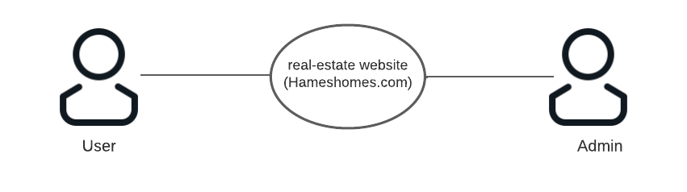

##### Fig. 2.2.2a Access Home Page

Brief Description:

User uses the hameshomes.com real-estate website to access the home page

Initial step-by-step description:

For this use case to be initiated, the user (user or admin) can use the website.

1. The user connects to the website using a web browser.
2. The user clicks on the hameshomes.com logo and gets redirected to the home page.

2.2.2b. Use Case: manage content

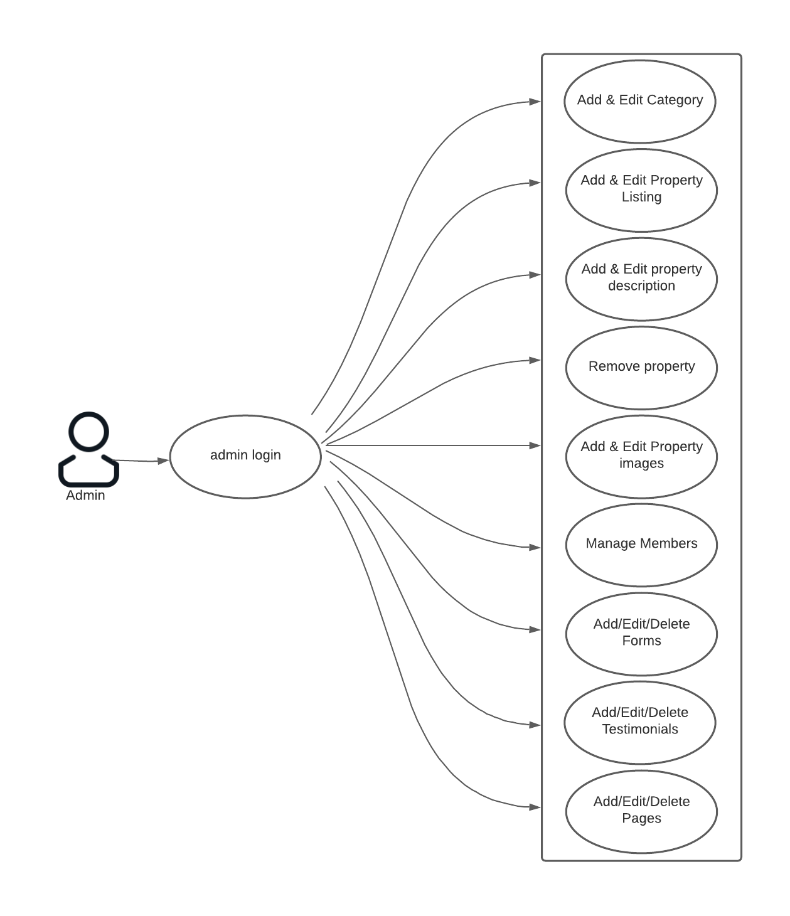

##### Fig. 2.2.2b Manage Content

Brief Description:

The Admin chooses to create a new category

Admin should be on the admin site by login with administrator credentials.



2.2.2c. Use Case: Admin Login

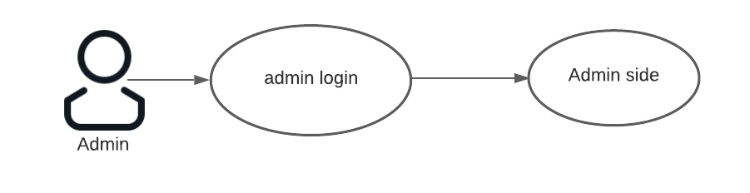

##### Fig. 2.2.2.c Admin Login

Brief Description:

The Admin can login on the website with the admin credentials and after that he/she will get redirected to the admin side of the website where the admin can manage the content of the website.

Initial step-by-step description:

1. The User selects the “Login” link.
2. The user enters the ID and Password to login.
3. If the user is already registered and credentials are correct, he successfully gets logged in.
4. Else it displays an error message.

2.2.2d. Use Case: User selects, filter, view, rent or buy property

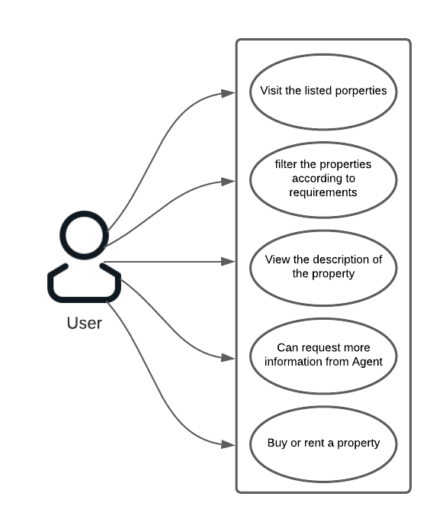



##### Fig. 2.4 User selects, filter, view, rent or buy property

Brief Description:

The user visits the site and view the listed properties and can filter them according to the requirements.  
After that user can buy or rent a property of his/her choice.

Initial step-by-step description:

For this use case initiated, following steps should be followed:

* + user should visit the “View Our Homes” page to view the listed property.
  + User can view the description of the property by clicking on the thumbnail of the property.
  + User can also ask for more information by filling up the “contact us” form on every property detail page.
  + User can also call the agent as the contact no. is also provided on the same page.



###### Non-functional requirements

There are requirements that are not functional in nature. Specifically, these are the constraints the system must work within.

The web site must be compatible with Internet Explorer web browser.



##### Requirement specifications

###### External interface specifications

None

###### Functional Requirements

**Table 2.2 Access Home Page**

|  |  |
| --- | --- |
| **Use Case Name:** | Access Home Page |
| **Priority** | Essential |
| **Trigger** | Menu selection |
| **Precondition** | User is on the home page. |
| **Basic Path** | 1. The user connects to the system using a web browser. 2. The user selects the Home link on the website home page. 3. The system passes the user to the   website Home Page. |
| **Alternate Path** | N/A |
| **Postcondition** | The User is on the Home Page |
| **Exception Path** | If there is a connection failure the website returns to the wait state |
| **Other** |  |

**Table 2.3 Admin Login or Signup**

|  |  |
| --- | --- |
| **Use Case Name:** | User Login or Signup |
| **Priority** | Essential |
| **Trigger** | Selects |
| **Precondition** | The User is on the Home Page |



|  |  |
| --- | --- |
| **Basic Path** | 1. The User selects the “Login” link. 2. The user enters the ID and Password to login. 3. If the user is already registered and credentials are correct, he successfully gets logged in. 4. Else it displays an error message. |
| **Alternate Path** | If after three attempts to match the name and password the website will return a message and block the user from the section. |
| **Postcondition** | The user is on the home page. |
| **Exception Path** | If the connection is terminated before the form is submitted, the fields are all cleared and the website is returned to the wait state. |
| **Other** |  |

**Table 2.4 Manage Content**

|  |  |
| --- | --- |
| **Use Case Name:** | Manage Content |
| **Priority** | Essential |



|  |  |
| --- | --- |
| **Trigger** | Menu selection |
| **Precondition** | The Admin must be logged in and on any of the pages (Published pages/Dashboard) |
| **Basic Path** | 1. The Admin selects the page he wants to edit. 2. Edit the content and then publish it again. 3. Admin can add new members and assign the role of administrators to them through ‘Members section’ 4. Admin can view the form results from admin dashboard. 5. Admin can view and print the financing applications through the listing of the applications under ‘Manage Financing Application’ section. 6. Admin can add/edit/delete a testimonial under ‘Manage Testimonial’ section on admin dashboard. 7. Admin can add a property under the ‘Our Homes’ through sitemap. 8. Admin can assign attributes and categories to the property which needs to be displayed. 9. All this data is then stored in the database according the tables created for each section. |
| **Alternate Path** | N/A |
| **Postcondition** | A record is created or updated in the related Table of the Database. |
| **Exception Path** | 1. If the connection is terminated before the form is submitted, the fields are cleared and the website is returned to the wait state. 2. If the connection is terminated after the form is submitted, but before the Admin   is returned to the Admin Home Page, the |
|  | record is created in the Table of the  Database. |
| **Other** |  |



**Table 2.5 User selects, filter, view, rent or buy property, apply for a job or financing.**

|  |  |
| --- | --- |
| **Use Case Name:** | User selects, filter, view, rent or buy property, apply for a job or financing. |
| **Priority** | Essential |
| **Trigger** | Menu selection |
| **Precondition** | User is on the home page. |
| **Basic Path** | * + - 1. The user clicks on ‘View Our homes’ button.       2. Then he filters the list of properties from the option present.       3. The user then click on any of the property he wants to see.       4. The user can request more information about the property by filling the form present below the property description.       5. The user clicks on ‘Financing Application’ under the ‘Financing’ Page.       6. The user then fills all the information if he wants the financing.       7. The user clicks on ‘Employment’ under the ‘About Us’ Page.       8. The user then fills the form if wants to apply for the job.       9. All this data is stored in the database.       10. The admin is notified via email whenever there is a submission |



|  |  |
| --- | --- |
| **Alternate Path** |  |
| **Postcondition** | The student will get the result and it is stored in the database. |
| **Exception Path** | 1. If the connection is terminated before the form is submitted, the fields are cleared and the website is returned to the wait  state. |
| **Other** |  |

* 1. **Hardware Specification Client Side:**
* Internet explorer or Google chrome or Fire fox or safari
* Processor: Intel i3 or above.
* RAM : 2 GB
* Hard Disk : 512GB

##### Server Side:

* Processor: Intel i3 or above.
* RAM : 1 GB
* Disk space : 4GB

##### Software Specification



* Concrete CMS
* Languages
* PHP
* Javascript
* HTML
* Bootstrap
* CSS
* GITHUB



* PHPStorm
* Xampp
* Jenkins
* Mysql Workbench

##### Data Base Server:

* SQL Server

##### Hardware and Software Requirements in detail Hardware Requirements:

* Processor: Intel i3 or above.
* Internet explorer or Google chrome or Fire fox or safari
* RAM : 1 GB
* Hard Disk : 80GB
* Disk space : 4GB

##### Software Requirements:

* PHPstorm
* PhpStorm is perfect for working with Symfony, Laravel, Drupal, WordPress, Zend Framework, Magento, Joomla!, CakePHP, Yii, and other frameworks.
* PhpStorm is renowned for its zero-configuration Visual Debugger, providing extraordinary insight into what goes on in your application at every step. It works with Xdebug and Zend Debugger, and can be used both locally and remotely. Unit Testing with PHPUnit, BDD with Behat and profiler integration are all also available.
* Concrete CMS
* Concrete CMS is an open source content management system for teams. A website builder with build in tools make editing content easy.



# CHAPTER – III

***SYSTEM ANALYSIS AND DESIGN***



### System Analysis and Design

##### Study & Weaknesses of Current System Current System

The current system of real-estate is highly unorganized and very difficult in terms of finding a proper, affordable and nice place. In the current system operations and accessibility of real estate are in very poor condition. It is not much user-friendly and economic. There are few things that needs to be done before buying or selling a property such as:

* + - Finding a suitable place
    - Validating the place
    - To evaluate the value and size of the place
    - Find proper banks for financing
    - Finding proper insurance companies

##### Weaknesses in Current System

The current system is as mentioned earlier very complicated and expensive as compared to the new system. It also wastes the precious time of the user/customer.

There is a need of lot of improvement in the current real estate system. As this system is very much complex and not at all transparent. Many malpractices can be played in this system because of less security and less authorization. People make wrongs investments and have to suffer with losses just because they get bad advises related to property or someone play’s a fraud with them.

Thus, the current system is in every way ineffective for buying/selling/renting properties in these days when time is more costly than anything this system wastes a lot of time of the customer and also losses a lot of money because of frauds and all the malpractices.



##### Requirements of New System

* + 1. **User Requirements**

The User requirements for the new system are to make the system fast, flexible, less prone to errors and reduce expenses and save time.

* + - * Time can be saved in finding the property as before the user have to go find a suitable property now with our system a user can find filter and buy/rent the property just by siting at home and just scrolling through our website.
      * Our website can also reduce the extensive paper work that can save a lot of time for the customer and also it is environmentally safe as less use of paper.
      * People can manage their property related details easily on this website which will help them in flexibly using the resource and also it makes the processing fast.
      * People who want to buy or rent a flat but don’t have much time to go and visit the site physically can use this website and do all the things needed just by sitting at a place.

##### Feasibility Study

A key part of the preliminary investigation that reviews anticipated costs and benefits and recommends a course of action based on operational, technical, economic, and time factors. The purpose of the study is to determine if the systems request should proceed further.

##### Does the New System Contribute to the Overall Objectives of the Organization?

The new system would contribute to the overall objectives to of the organization. It would provide a quick, error free and cost effective solution to the current process. It would provide a solution to many issues in the current system. As the new system is flexible and scalable it can also be upgraded and extended to meet other complex requirements which may be raised in the future. However it is up to the organization to upgrade or extend it.



##### Can the New System be Implemented Using Current Technology?

The organization has a computer laboratory which has about 50 machines connected by Internet LAN and managed by a server. It would be very easy to set up the system in the current environment as the application is web based it does not require to be installed on every machine. The database and IIS are set up on the server and , the system can be started as quick as required by the management.

##### Features of the New System.

The new system has been designed as per the user requirements so as to fulfill almost all them.

##### Quick Scheduling

Exams can be created very quickly as compared to the existing system as it allows the use of previously entered questions to be used again. It saves time required to get the question papers printed and distributed before the students are allowed to appear for the examination. Questions entered once can be accessed by students as soon as they login to their account.

##### Immediate Results and Solutions

One of the most important draw backs of the current system is that the faculties are required to check the answer papers which is again a lengthy process and prone to errors. The new system will generate the result as soon as the test is finished by the user and will also store it in the database for further usage. The solution is also available as soon as the questions are inserted in the database.

##### Easy to Store and Retrieve Information

The new system makes it easy to store and retrieve information as required and does not involve storing information in separate sheets or papers. It thus saves data management problems faced in the current system as it has a Database Management System of itown which allows 33 reports to be generated when needed.

##### Cost Effective

One of the main reasons of the new system is its cost effectiveness. It saves the amount spend on stationary as well as overall cost of conducting an examination which also involves paying supervisors, paper checkers, question paper printers etc.



##### Data Flow Diagram (DFD)

The DFD (also known as *bubble chart*) is a simple graphical formalism that can be used to represent a system in terms of the input data into the system, various processes carried on these data, and the output data generated by the system.

The main reason why the DFD technique is so popular is because the fact that the DFD is a very simple formalism – it is simple to understand and use. A DFD model uses a very limited number of primitive symbols to represent the functions performed by a system and the data flow among the functions. Starting with a set of high-level functions that a system performs, a DFD model hierarchy represents various sub-functions.

##### Fig. 3.1 USER DFD Level 2

##### 



**Fig. 3.2 Admin (DFD Level 2)**

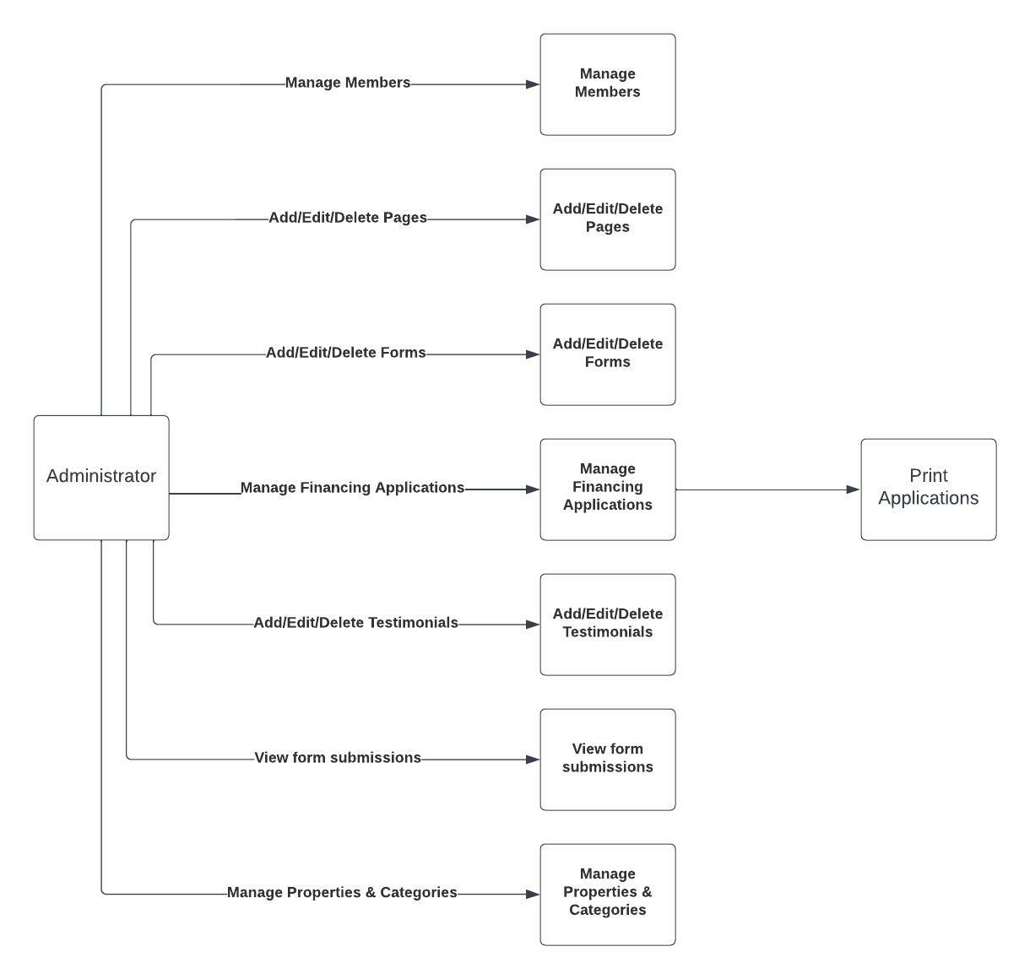



* 1. **UML Modelling**

**3.6.1 Activity Diagram**

**3.6.1a. Activity Diagram for Admin**

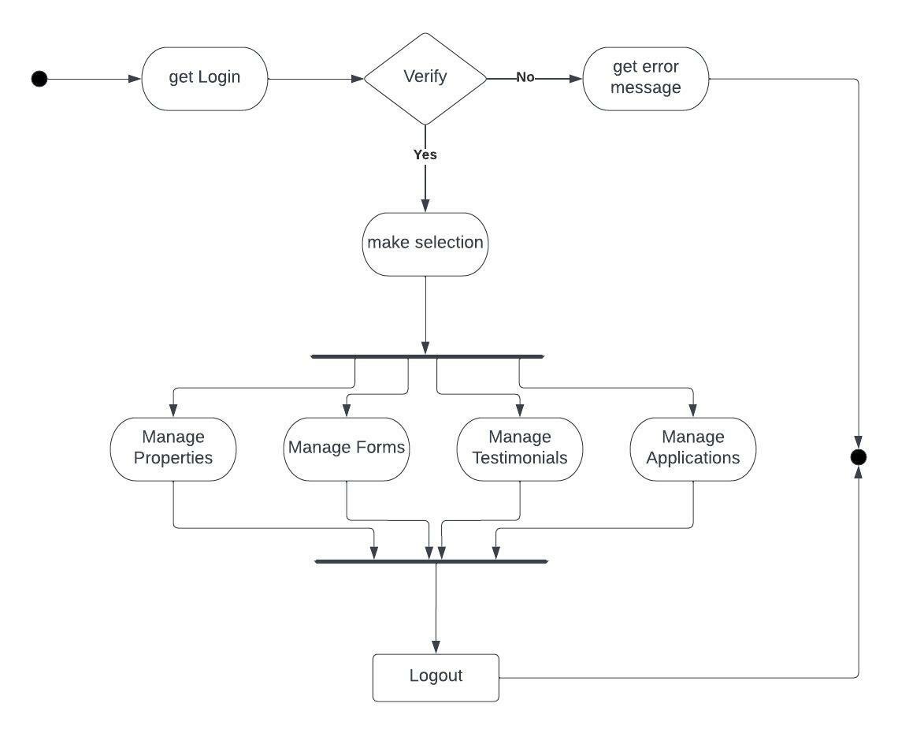

**Fig. 3.10 Activity Diagram for Admin**

**3.6.1b. Activity Diagram for User**



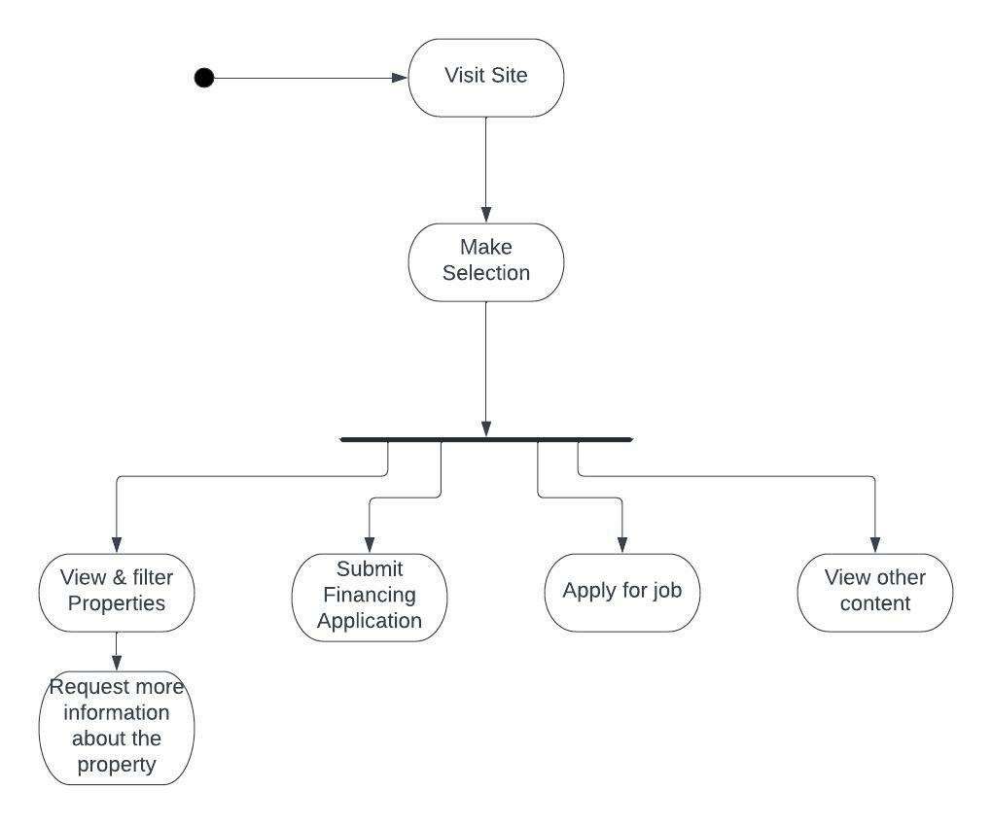

**Fig. 3.11 Activity Diagram for User**



**3.6.2. Context Diagram**

The context diagram is a top-level view of an information system that shows the boundaries and scope. It describes the main objective of the system and the entities involved.

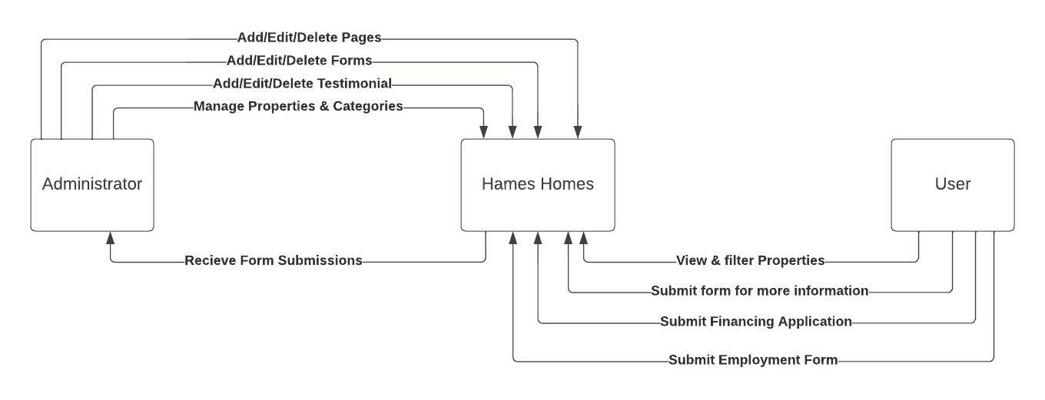

**Fig. 3.12 Context Diagram**



***CHAPTER – IV DATA DICTIONARY***



**Data Dictionary**

A data dictionary is a catalog-a-repository of the elements in a system. As the name suggests, their elements center on data and the way they are structured to meet user requirements and organization needs. In a data dictionary you will find a list of all the elements composing the data flowing through a system. The major elements are data flows, data stores and processes. The data dictionary stores details and descriptions of these elements.

If analysis want to know characters are in a data item by what other names it is referenced in the system, or where it is referenced in the system, or where it is issued in the system, they should be able to find the answers in issued in the system, they should be able to find the answer in properly developed data dictionary.

The Dictionary contains two types of description for the data following through the system.

##### Data Elements

The most fundamental data is the elements. They are building blocks for all other data in the system. Data elements are also alternatively known as fields, data item or elementary item.

##### Data Structure

A data structure is a set if items that are related to one another and described a components in the system.

### Table Details

##### Table 4.1. Admin Login

|  |  |  |  |  |
| --- | --- | --- | --- | --- |
| **Field Name** | **Description** | **Constraints** | **Size** | **Data Type** |
| Username | Unique username  of the user |  | 50 | varchar |
| Password | User password |  | 50 | varchar |



**Table 4.2. Category**

|  |  |  |  |  |
| --- | --- | --- | --- | --- |
| **Field Name** | **Description** | **Constraints** | **Size** | **Data Type** |
| CategoryId | Unique id for  categories | Primary key | 4 | int |
| Name | Name of  categories |  | 50 | varchar |

**Table 4.3. Request Details**

|  |  |  |  |  |
| --- | --- | --- | --- | --- |
| **Field Name** | **Description** | **Constraints** | **Size** | **Data Type** |
| FullName | Name of the user |  | 50 | Varchar |
| Email | Email of the  user |  | 50 | Varchar |
| Phone | Contact no. of user |  | 50 | integer |
| Request | User requests. |  | 50 | Varchar |

**Table 4.4. Contact Us details**

|  |  |  |  |  |
| --- | --- | --- | --- | --- |
| **Field Name** | **Description** | **Constraints** | **Size** | **Data Type** |
| FullName | Name of the user |  | 50 | Varchar |
| Email | Email of the  user |  | 50 | Varchar |
| Address | Address of the user |  | 50 | Varchar |
| Phone | User’s contact no. |  | 50 | Integer |
| Timetocontact | Best time to contact back user |  | 50 | Date and time |
| Fax | User’s fax no. |  | 50 | Integer |
| Contact Method | How user like to get contacted back |  | 50 | Varchar |
| Question/comment | User’s additional question or comment |  | 120 | Varchar |



**Table 4.5. Property details**

|  |  |  |  |  |
| --- | --- | --- | --- | --- |
| **Field Name** | **Description** | **Constraints** | **Size** | **Data Type** |
| PropUniqueId | Unique Id for property |  | 50 | Varchar |
| Name | Name of the property |  | 50 | Varchar |
| Description | Description of the property |  | 50 | Varchar |
| Specifications | Extra specification of the property |  | 50 | Varchar |
| Price | Price of the property to sell or buy or rent. |  | 50 | Varchar |
|  |  |  |  |  |

**Table 4.5. Testimonials**

|  |  |  |  |  |
| --- | --- | --- | --- | --- |
| **Field Name** | **Description** | **Constraints** | **Size** | **Data Type** |
| TestUniqueId | Unique Id for property |  | 50 | Varchar |
| Name | Name of the property |  | 50 | Varchar |
| Description | Description of the property |  | 50 | Varchar |



**Table 4.5. Financial Applications**

|  |  |  |  |  |
| --- | --- | --- | --- | --- |
| **Field Name** | **Description** | **Constraints** | **Size** | **Data Type** |
| applicationId | Unique Id for financial applications |  | 50 | Varchar |
| Name | Name of the user |  | 50 | Varchar |
| Address | Address of the User |  | 50 | Varchar |



**Table 4.5. Employment Applications**

|  |  |  |  |  |
| --- | --- | --- | --- | --- |
| **Field Name** | **Description** | **Constraints** | **Size** | **Data Type** |
| Fullname | Full name of the applicant |  | 50 | Varchar |
| DOB | Date of birth of the applicant |  | 50 | Varchar |
| Address | Address of the applicant |  | 50 | Varchar |
| Email | Email of the applicant |  | 50 | Varchar |
| Phone Number | Phone No. of the applicant |  | 50 | Integer |
| Interest | Interest of the applicant |  | 50 | Varchar |
| Referral | Name of the person who referred |  | 100 | Varchar |
| About | About the applicant itself |  | 100 | Varchar |



* 1. **E-R Diagram**

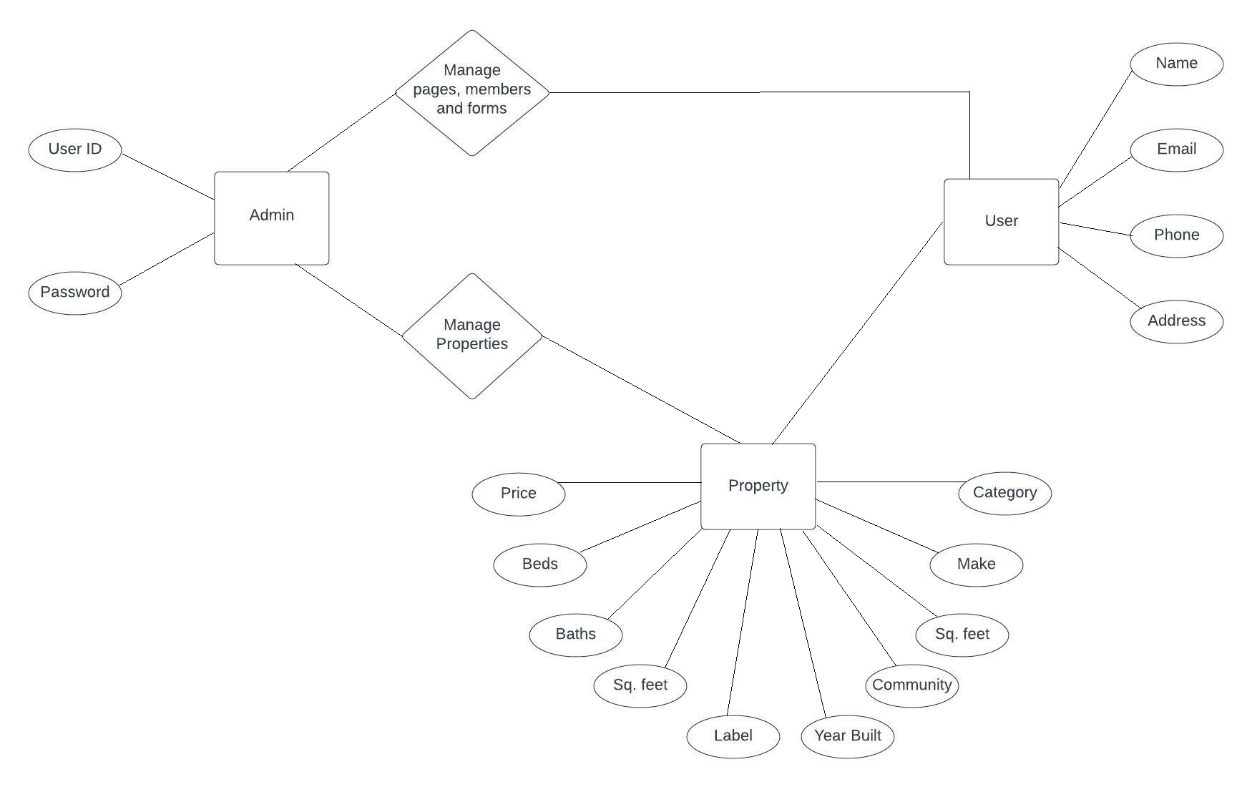

**Fig. 4.1 E-R Diagram**



***CHAPTER – V SCREEN SHOTS***



* 1. **User Side**
     1. **Home Page**



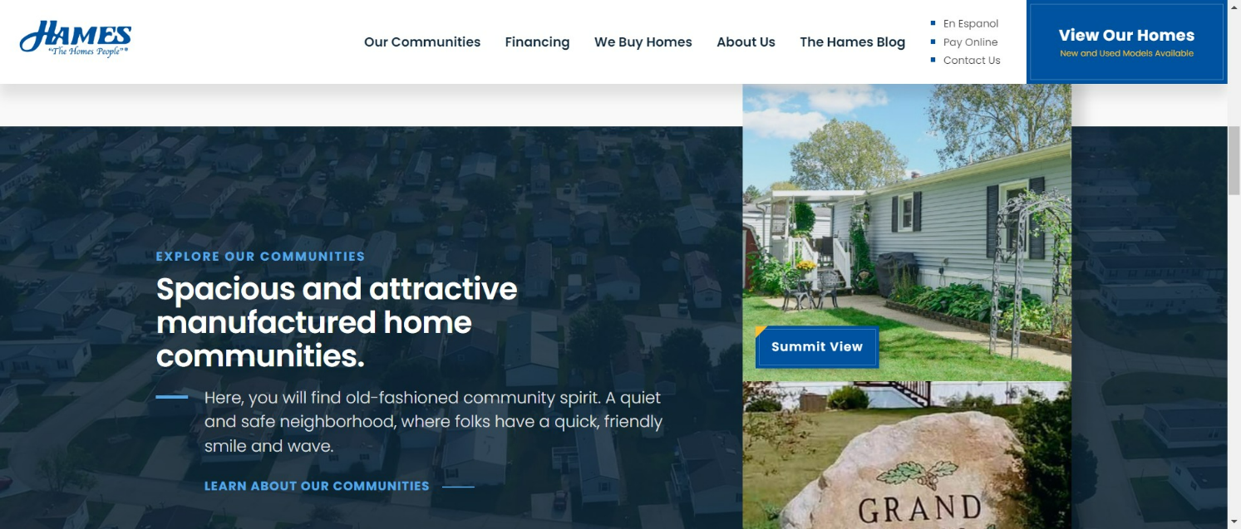

* + 1. **Admin Login**

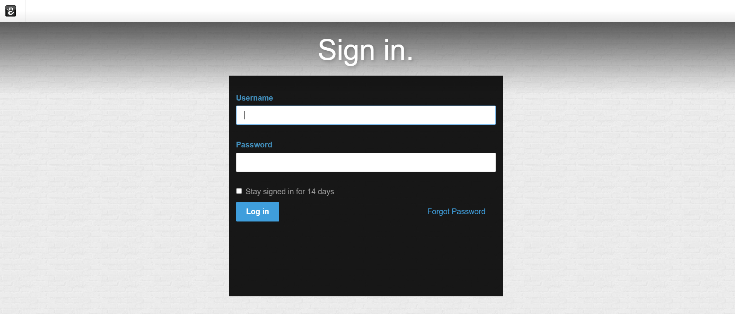



* + 1. **Global Header**



* + 1. **Our Communities Page**

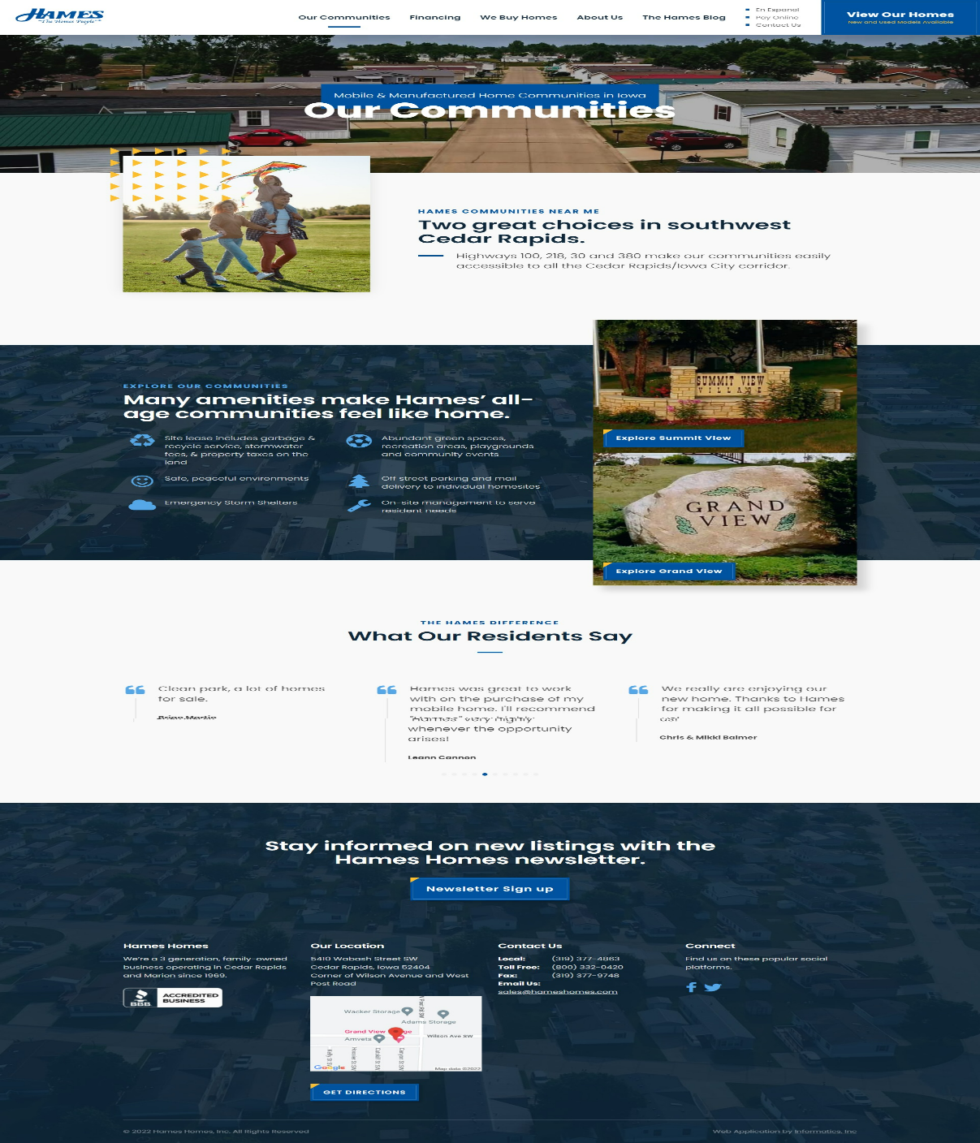



* + 1. **Financing Page**

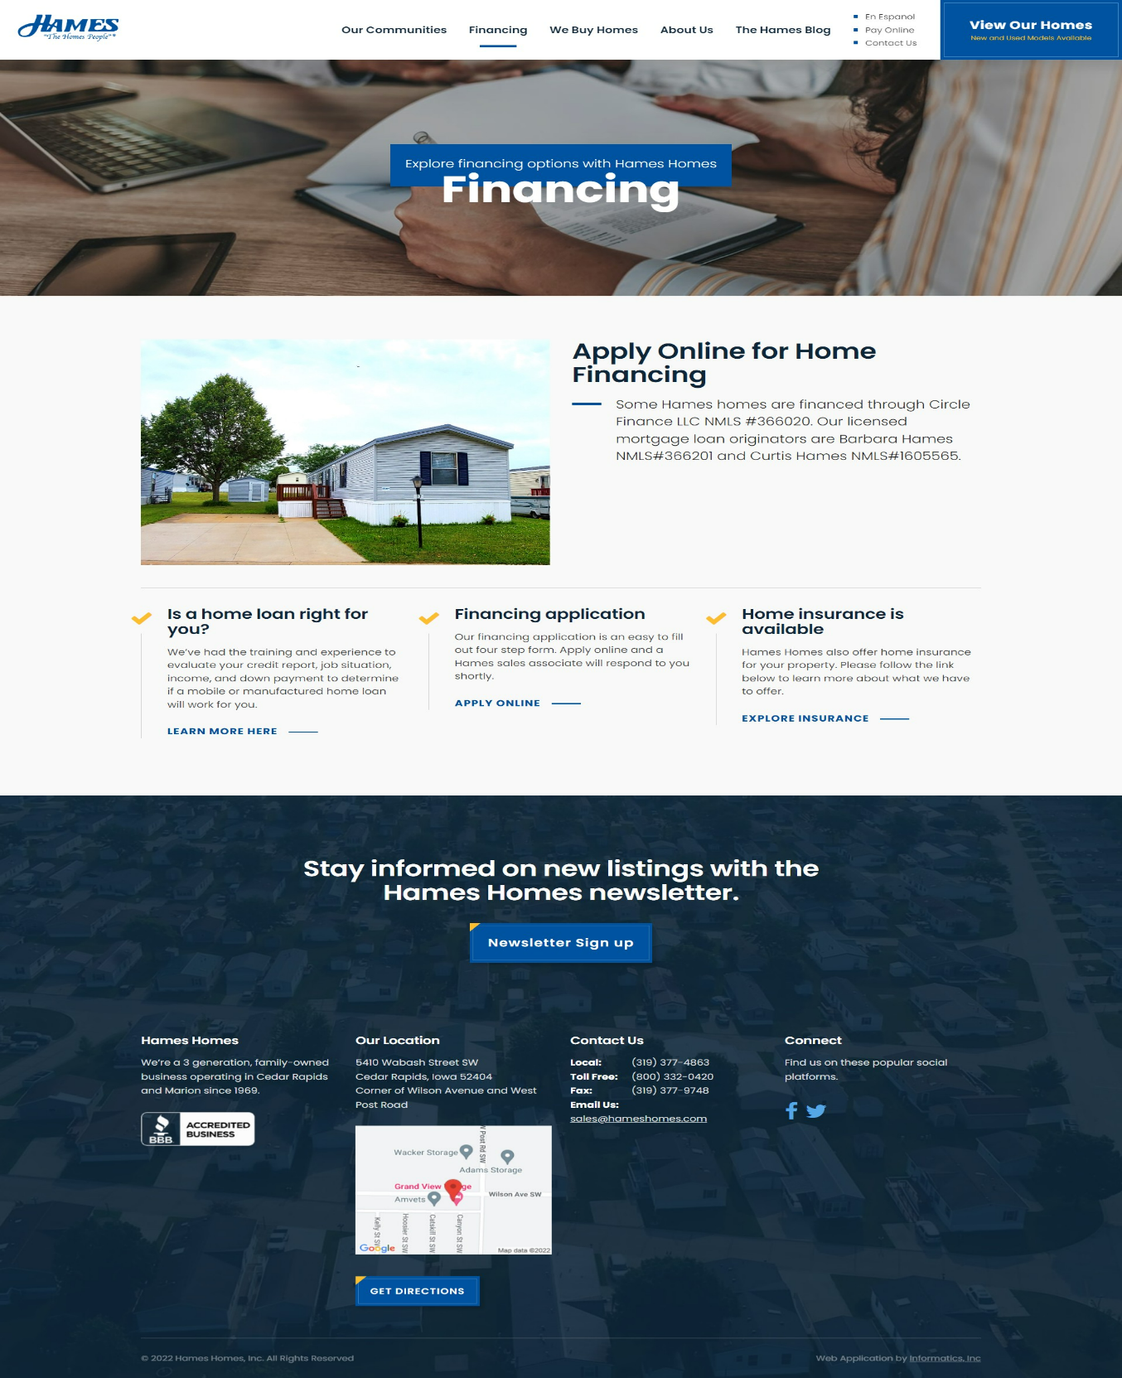

* + 1. **“We Buy Homes” Page**

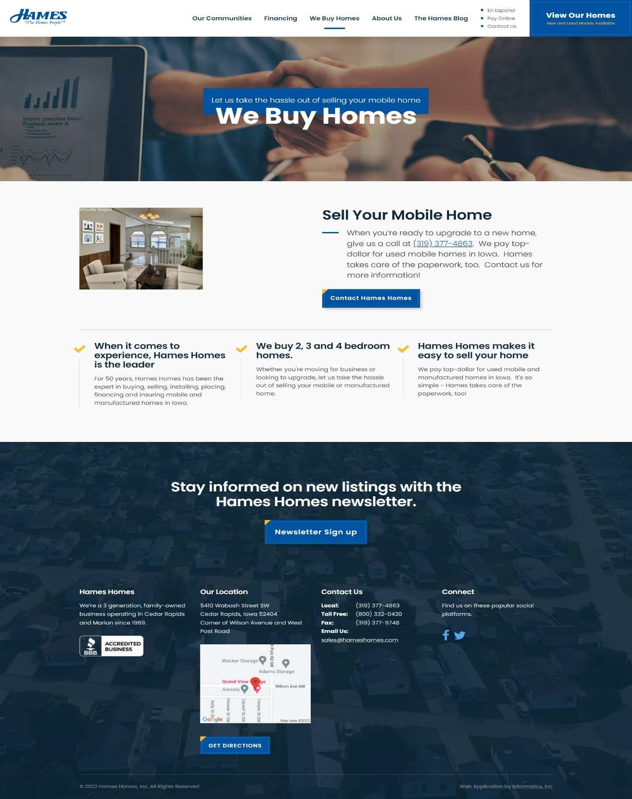



* + 1. **About Us Page**



* + 1. **Blog Page**

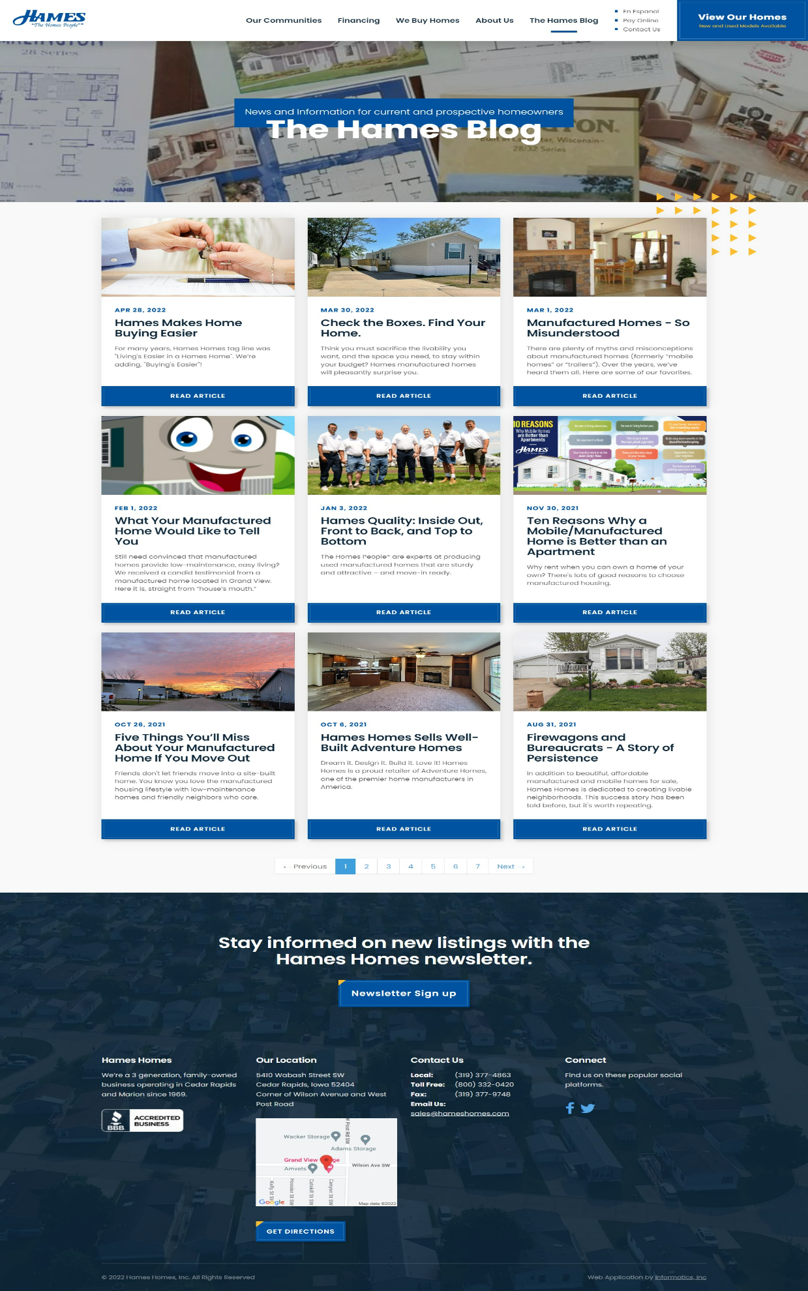



**5.1.10. Our Homes Page**

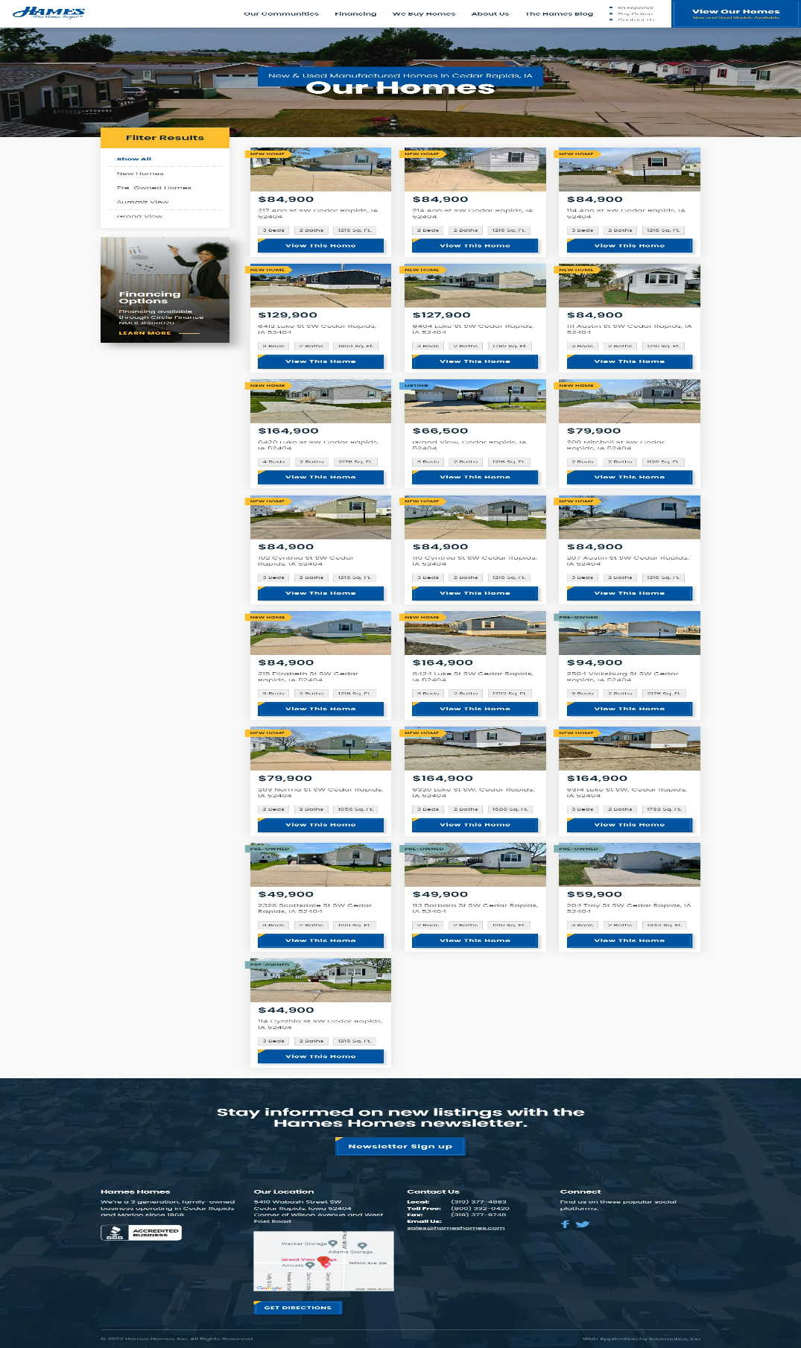



**5.1.11. Property detail page**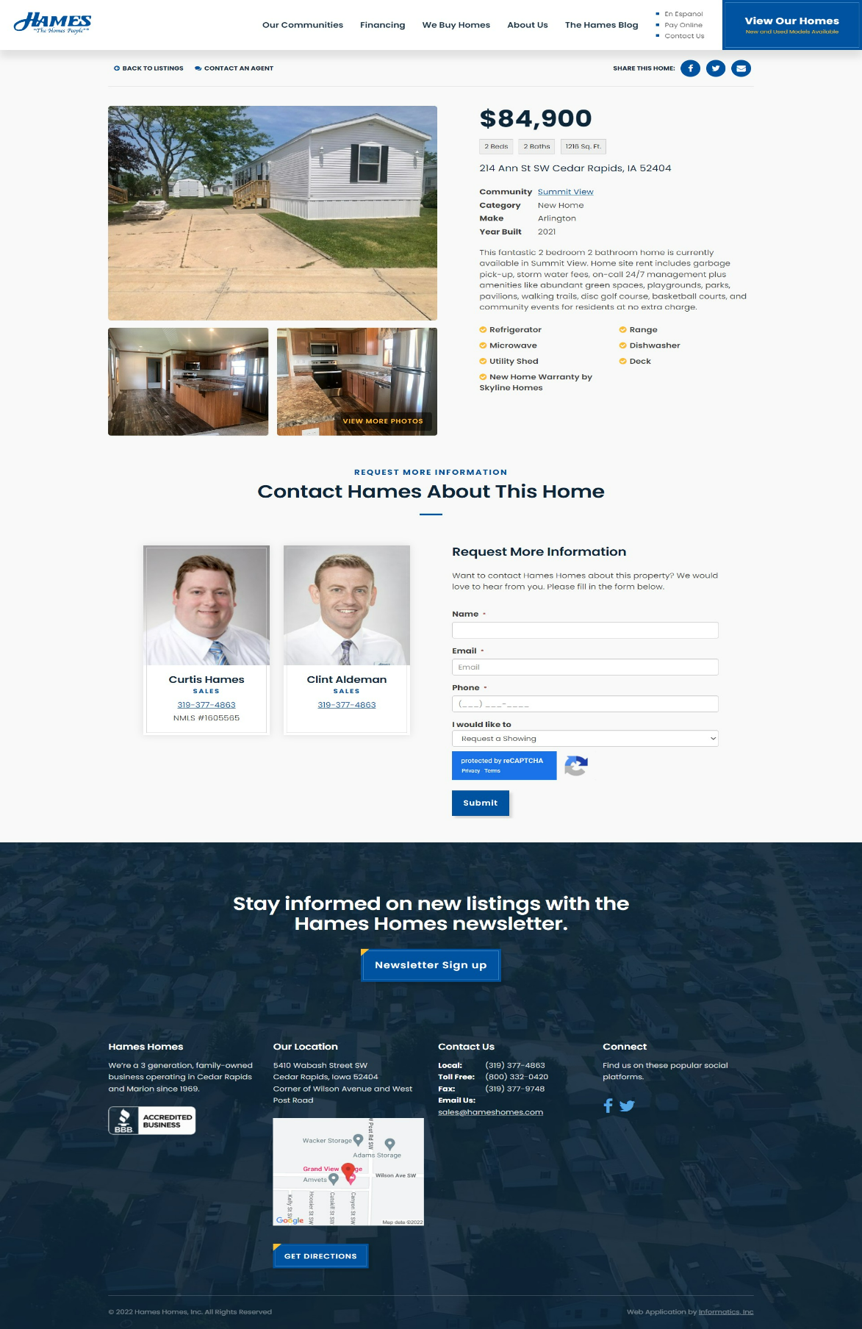

**5.1.12. Property categories   
  
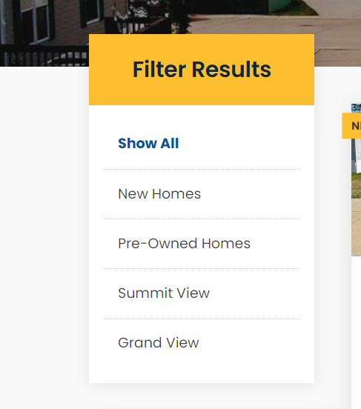**



**5.1.12. Financial Application page**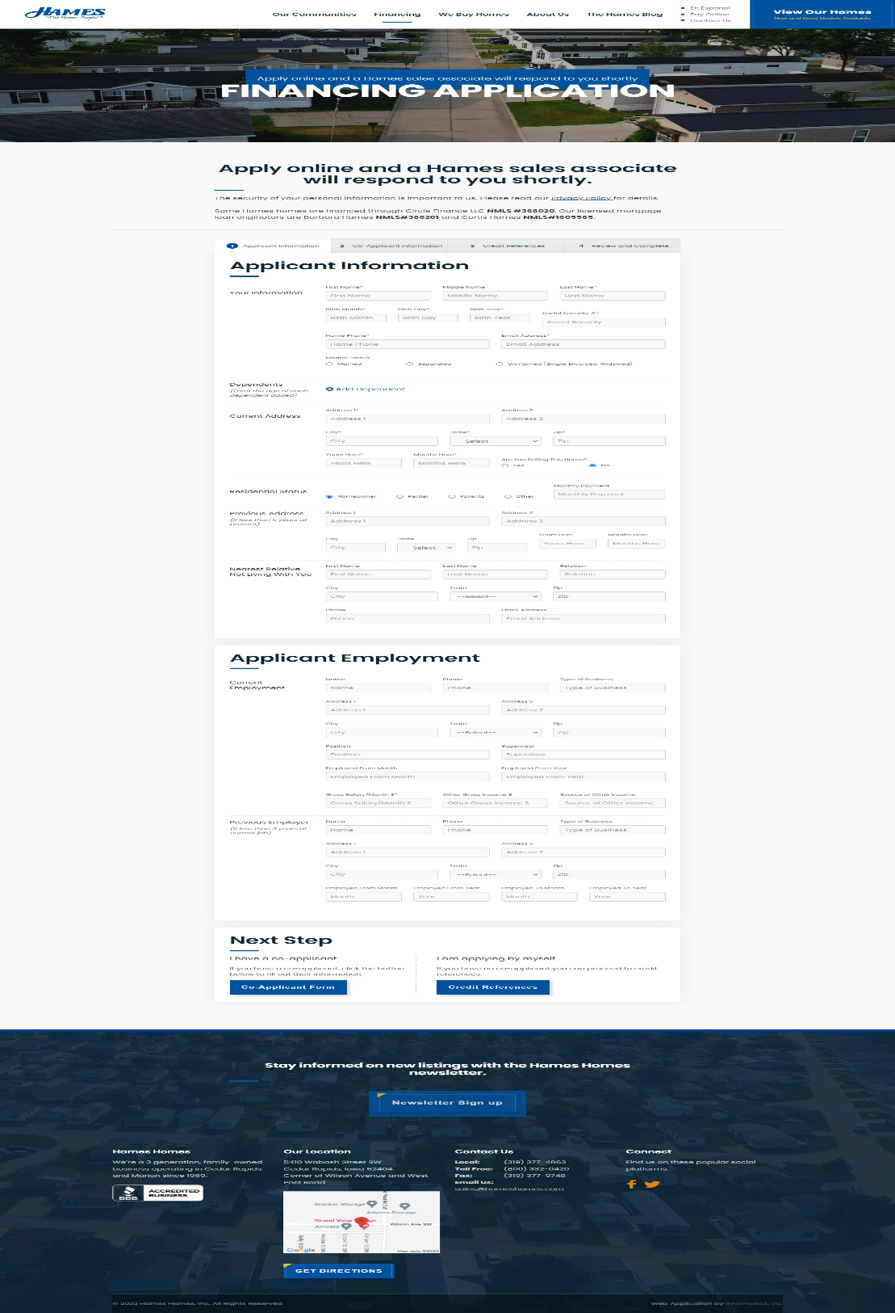



***CHAPTER – VI TESTING***



**Testing**

**Testing Methodology**

Companies rely on software more than ever to provide and manage information with strategic and operational importance and to provide key decision support. Rising customer expectations for fault-free, requirements-exact software have increased awareness of the importance of software testing as a critical activity.

We begin the testing process by developing a comprehensive plan to test the general functionality and special features on a variety of platform combinations. Strict quality control procedures are used. The process verifies that the application meets the requirements specified in the system requirements document and is bug free. At the end of each testing day, we prepare a summary of completed and failed tests. Applications are not allowed to launch until all identified problems are fixed. A report is prepared at the end of testing to show exactly what was tested and to list the final outcomes.

Our software testing methodology is applied in three distinct phases: unit testing, system testing, and acceptance were testing.

**Unit Testing**: The programmers conduct unit testing during the development phase. Programmers can test their specific functionality individually or with other units. However, unit testing is designed to test small pieces of functionality rather than the system as a whole. This allows the programmers to conduct the first round of testing to eliminate bugs before they reach the testing staff. In unit testing the analyst tests the programs making up a system.

For this reason, unit testing is sometimes called program testing. Unit testing gives stress on the modules independently of one another, to find errors. This helps the tester in detecting errors in coding and logic that are contained within that module alone. The errors resulting from the interaction between modules are initially avoided.

For example, a hotel information system consists of modules to handle reservations; guest checking and checkout; restaurant, room service and miscellaneous charges; convention activities; and accounts receivable billing. For each, it provides the ability to enter, modify or retrieve data and respond to different types of inquiries or print reports. The test cases needed for unit testing should exercise each condition and option.



Unit testing can be performed from the bottom up, starting with smallest and lowest-level modules and proceeding one at a time. For each module in bottom-up testing a short program is used to execute the module and provides the needed data, so that the module is asked to perform the way it will when embedded within the larger system.

**System Testing*:*** The objective of system testing is to ensure that all individual programs are working as expected, that the programs link together to meet the requirements specified and to ensure that the computer system and the associated clerical and other procedures work together.

The initial phase of system testing is the responsibility of the analyst who determines what conditions are to be tested, generates test data, produced a schedule of expected results, runs the tests and compares the computer produced results with the expected results with the expected results.

The analyst may also be involved in procedures testing. When the analyst is satisfied that the system is working properly, he hands it over to the users for testing. The importance of system testing by the user must be stressed. Ultimately it is the user must verify the system and give the go-ahead.

During testing, the system is used experimentally to ensure that the software does not fail, i.e., that it will run according to its specifications and in the way users expect it to. Special test data is input for processing (test plan) and the results are examined to locate unexpected results.

A limited number of users may also be allowed to use the system so analysts can see whether they try to use it in unexpected ways. It is preferably to find these surprises before the organization implements the system and depends on it. In many organizations, testing is performed by persons other than those who write the original programs. Using persons who do not know how certain parts were designed or programmed ensures more complete and unbiased testing and more reliable software.

The system is tested as a complete, integrated system. System testing first occurs in the development environment but eventually is conducted in the production environment. Functionality and performance testing are designed to catch bugs in the system, unexpected results, or other ways in which the system does not meet the stated requirements.

The testers create detailed scenarios to test the strength and limits of the system, trying to break it if possible. Editorial reviews not only correct typographical and grammatical errors, but also



improve the system’s overall usability by ensuring that on-screen language is clear and helpful to users. Accessibility reviews ensure that the system is accessible to users with disabilities.

System testing consists of the following five steps:

1. Program testing
2. String testing
3. System testing
4. System documentation
5. User acceptance testing

##### Program Testing

A program represents the logical elements of a system. For a program to run satisfactorily, it must compile and test data correctly and tie in properly with other programs. It is the responsibility of a programmer to have an error free program. At

The time of testing the system, there exists two types of errors that should be checked. These errors are syntax and logic.

A syntax error is a program statement that violates one or more rules of the language in which it is written. An improperly defined field dimension or omitted key words are common syntax errors. These errors are shown through error messages generated by the computer. A logic error, on the other hand, deals with incorrect data fields out of range items, and invalid combinations.

Since the logical errors are not detected by compiler, the programmer must examine the output carefully to detect them. When a program is tested, the actual output is compared with the expected output. When there is a discrepancy, the sequence of the instructions, must be traced to determine the problem. The process is facilitated by breaking the program down into self- contained portions, each of which can be checked at certain key points.

##### String Testing

Programs are invariably related to one another and interact in a total system. Each program is tested to see whether it conforms to related programs in the system. Each part of the system is tested against the entire module with both test and live data before the whole system is ready to be tested.



##### System Testing

System testing is designed to uncover weaknesses that were not found in earlier tests. This includes forced system failure and validation of total system as it will be implemented by its user in the operational environment. Under this testing, generally we

Take low volumes of transactions based on live data. This volume is increased until the maximum level for each transaction type is reached.

The total system is also tested for recovery and fallback after various major failures to ensure that no data are lost during the emergency.

All this is done with the old system still in operation. When we see that the proposed system is successful in the test, the old system is discontinued.

##### System Documentation

All design and test documentation should be well prepared and kept in the library for future reference. The library is the central location for maintenance of the new system.

##### User Acceptance Testing

An acceptance test has the objective of selling the user on the validity and reliability of the system. It verifies that the system's procedures operate to system specifications and that the integrity of important data is maintained. Performance of an acceptance test is actually the user's show. User motivation is very important for the successful performance of the system. After that a comprehensive test report is prepared. This report shows the system's tolerance, performance range, error rate and accuracy.



##### Table 6.1 Test Report with test data

|  |  |  |
| --- | --- | --- |
| **TEST REPORT WITH TEST DATA**  (To be filled by System Analyst/Programmer) | | |
| **Project Name : Real-Estate website (Hameshomes.com)** | | |
| **S No.** | **Testing Parameter** | **Observations** |
| A. | INTERFACE TESTING   1. User-friendliness 2. Consistent menus | OK NA |
| B. | CONTROL FLOW TESTING   1. IF-THEN-ELSE 2. DO WHILE 3. CASE-SWITCH | OK  OK OK |
| C. | VALIDATION TESTING   1. Check for improper or inconsistent typing 2. Check for erroneous initialization or default values 3. Check for incorrect variable names 4. Check for inconsistent Data Types 5. Check for relational/arithmetic operators | OK OK OK OK  OK |
| D. | DATA INTEGRITY/SECURITY TESTING   1. Data Insertion/ Deletion/ Updating 2. Boundary condition (Underflow, Overflow Exception) 3. Check for unauthorized access of data 4. Check for data availability | OK OK OK OK |



|  |  |  |
| --- | --- | --- |
| E. | EFFICIENCY TESTING   1. Throughput of the system 2. Response time of the system 3. Online disk storage required by the system 4. Primary memory required by the system | OK OK OK  OK |
| F. | ERROR HANDLING ROUTINES   1. Error description are intelligent/ understandable 2. Error recovery is smooth 3. All error handling routines are tested and executed at least once | OK OK OK |



***CHAPTER – VII***

***CONCLUSION AND FUTURE ENHANCEMENTS***



* 1. **Limitations**

The new system has been designed to meet almost all of the user requirements but it too has certain limitations some of which can be enhanced in the future enhancements or updates

##### No direct interaction between seller and buyer with admin intervention

The existing system allows the seller to contact the agent and then agent becomes an intermediate between seller and buyer for now there is no facility in which the seller and the buyer can directly talk to each other on the website itself. Like there is no chat window for the seller or the buyer.

##### Seller can’t list their properties own their own

The existing system doesn’t give the user to list its property on the website own their own, as of now the user have to contact the hameshomes.com admin for listing the property for rent or to sell.

##### Need to reduce complexity in the process of selling a property

The process that needs to be followed to sell a property on the site is a bit complex which can be optimized to reduce the complexity and attract more users towards the website.



### Future Enhancements

Enhancements are the perquisite for development of a system. Every existing system has proposed enhancements which make it better and easier to use and more secure. The enhancements that have been proposed for this system are listed here.

##### Website can be used for better investment plans and also can provide advisors.

##### It can be converted to a standard application for more remote work.

##### This website can be used in educational institute visit purposes too.

##### Flags

### Conclusion

The development of software includes so many people like user system developer, user of system and the management, It is important to identify the system requirements by properly collecting required data to interact with supplier and customer of the system.

Proper design builds upon this foundation to give a blue print, which is actually implemented by the developers.

On realizing the importance of systematic documentation all the processes are implemented using a software engineering approach. Working in a live environment enables one to appreciate the intricacies involved in the System Development Life Cycle (SDLC).

We have gained a lot of practical knowledge from this project, which we think, shall make us stand in a good state in the future.



# CHAPTER – VIII BIBLIOGRAPHY



### Bibliography

* List of useful Websites
  + <https://concretecms.org>
  + <https://www.w3schools.com/html>
  + <https://www.javatpoint.com/javascript-tutorial>
  + <https://getbootstrap.com>
  + <https://github.com>